

Logic Analyzer Display System

Using Pmod OLEDrgb

**Submitted by:**

KANGULA JAI LAKSHMI

Roll no. – 160123735011

Branch – ECE (E1)

CHAITANYA BHARATHI INSTITUTE OF TECHNOLOGY

July 2025

# Abstract

This project presents the design and implementation of a miniature, FPGA-based logic analyzer display system using the Spartan-7 FPGA (XC7S50CSG324-1) boolean board and the Pmod OLEDrgb module. The objective was to create a system that could capture and visualize digital logic signals in real time on a small-scale OLED display without an external computer. Logic analyzers are essential tools for observing digital waveforms and understanding signal transitions. By using a compact 96x64 OLED display (SSD1331), this system can visualize real-time logic signals in a compact and user-friendly format. The project uses Verilog HDL for core logic and Vivado for synthesis and implementation. Key functionalities of the system include signal capture, SPI(Serial Peripheral Interface) communication with the OLED, and waveform rendering. This implementation acts as an educational and practical embedded systems application that aids in the analysis of digital systems. This report delves into the details of the project’s hardware and its Verilog logic, along with focusing on the system architecture and flow of information. It will give the reader a brief overview of the project's details.

**Aim**

The logic analyzer display project aimed to interface the Spartan-7 FPGA and the Pmod OLEDrgb module to display and analyze the signal samples.

# Introduction

In modern digital systems, logic analyzers are critical devices that allow engineers and developers to visualize and debug signal behavior. This project aims to develop a compact and functional logic analyzer display system using anar Xilinx Spartan-7 FPGA (XC7S50CSG324-1) and a Pmod OLEDrgb OLED module. The basic outcome is to provide a simple yet effective method to monitor logic levels in real-time on a small RGB display without the need for external computers or expensive debugging tools.  
  
The Spartan-7 FPGA offers flexibility and high-speed digital design capability, while the Pmod OLEDrgb display with its 96x64 pixel resolution, provides a compact medium to visualize digital signals. This system can capture 4-bit input logic signals, process them using Verilog logic, and then output the waveform data to the OLED display using SPI communication. There are a few features that are also embedded such as switching between test and real-time signals, controlling the speed, and freezing the signals. This project finds its use in academic learning, embedded system debugging, and as a baseline for larger digital analyzer systems.

# System Specifications and Tools Used

The project utilizes the following hardware and software components:  
  
• FPGA Board: Xilinx Spartan-7 XC7S50CSG324-1  
• Display Module: Digilent Pmod OLEDrgb (based on SSD1331 controller)  
• Display Resolution: 96 x 64 pixels  
• Color Format: 16-bit RGB (5-6-5)  
• Programming Language: Verilog HDL  
• Development Software: Xilinx Vivado 2020.2 or higher  
• Communication Interface: SPI ( Serial Peripheral Interface)  
• Input Channels: 4-bit digital signal input  
  
These specifications ensure a compact, real-time visualization system with low hardware overhead.

# Hardware Overview

1. Spartan-7 FPGA (XC7S50CSG324-1) boolean board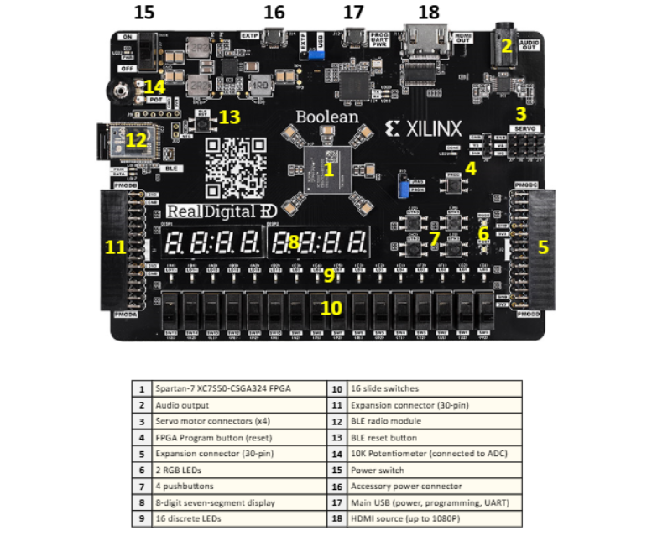
2. Pmod OLEDrgb Display Module

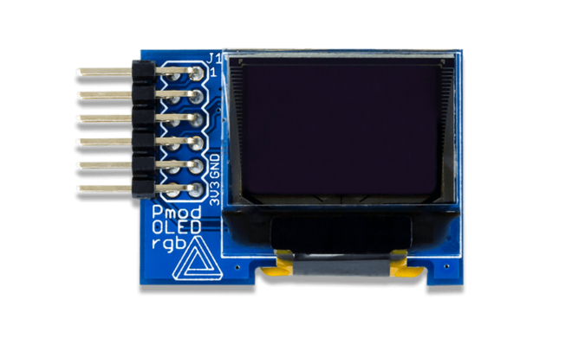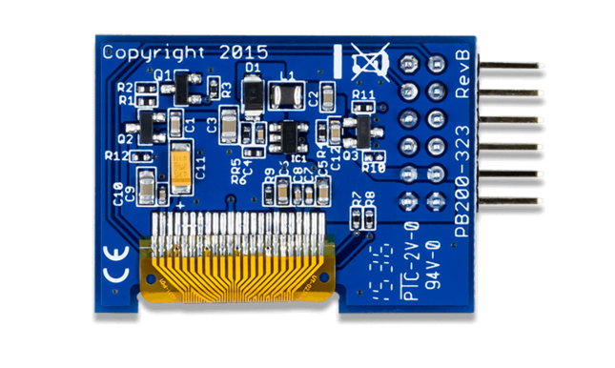

1. PMOD C Connector
2. Vivado Design Suite

# 4.Methodology

# System Design and Architecture

The logic analyzer display system is designed using a modular architecture comprising the following components:  
  
1. Top_module (also has) – Samples 4-bit input signals at the clock rate and stores them temporarily for rendering.  
2. Logic_display_pixel_gen – Translates signal samples into waveform pixel coordinates.  
3. SPI Master – Handles data transmission over SPI to the OLED.  
4. SSD1331_INIT – Manages initialization and graphics commands to SSD1331.  
  
These components are integrated through a top-level control module that synchronizes capture, process, and display operations. The following block diagram illustrates the high-level system design:

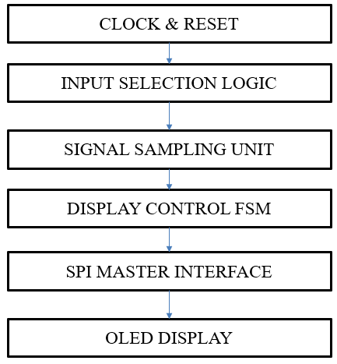

The design operates on a 100 MHz system clock and updates the display at user-selected speeds. The waveform rendering algorithm ensures scrolling effects with background refresh logic.

# Verilog Implementation

The project is developed entirely using Verilog HDL. Each major component of the system is written as a separate module and instantiated in the top-level design. The major modules include:  
  
• logic_display_pixel_gen.v – Signals samples from the external are converted to waveform pixel coordinates.  
• spi_master.v – Handles SPI communication with proper clock division and synchronization.  
• ssd1331_init.v – Sends initialization commands and drawing instructions to SSD1331.  
• top_logic_analyzer.v – Integrates all components and manages display logic.  
  
The design ensures pipelining of data to the OLED for real-time rendering. Below is a snippet of the top module declaration along with all the other modules.

**1.TOP MODULE**

**module top_logic_analyzer**(  
 input clk,

input rst,

input [3:0] logic_in_external,

input speed_switch,

input mode_select, // 1 = test signal mode, 0 = external input

input freeze_button, // 1 = freeze test signal counter

output sclk,

output mosi,

output cs,

output dc,

output res_n,

output vccen,

output pmoden

);

// SPI/Init Wiring

wire spi_done, init_done;

wire [7:0] spi_data;

wire spi_start;

// Sample buffer (96 pixels wide)

reg [3:0] sample_mem [0:95];

integer j;

// Sampling rate

reg [15:0] sample_counter = 0;

reg [15:0] sample_rate = 16'd50000;

// SPI drawing

wire sclk_int, mosi_int, cs_int, dc_init, res_n_init;

reg draw_dc = 0;

reg draw_spi_start = 0;

reg [7:0] draw_spi_data = 0;

reg drawing = 0;

// FSM coordinates

reg [6:0] x = 0;

reg [5:0] y = 0;

reg [4:0] state = 0;

// Pixel color

wire [15:0] pixel_color;

// Internal counter-based test signal generator

reg [31:0] counter = 0;

always @(posedge clk) begin

if (!freeze_button) // freeze when button is held

counter <= counter + 1;

end

wire [3:0] logic_test;

assign logic_test[0] = counter[24]; // CH0 - slow

assign logic_test[1] = counter[23]; // CH1 - medium

assign logic_test[2] = counter[22]; // CH2 - faster

assign logic_test[3] = counter[21] ^ counter[20]; // CH3 - dynamic XOR

// Select input source

wire [3:0] logic_in;

assign logic_in = (mode_select) ? logic_test : logic_in_external;

// Sample and scroll logic

always @(posedge clk) begin

sample_rate <= (speed_switch) ? 16'd10000 : 16'd50000;

sample_counter <= sample_counter + 1;

if (sample_counter >= sample_rate) begin

sample_counter <= 0;

for (j = 0; j < 95; j = j + 1)

sample_mem[j] <= sample_mem[j + 1];

sample_mem[95] <= logic_in;

end

end

// OLED Init FSM

ssd1331_init oled_init (

.clk(clk),

.rst(rst),

.spi_data(spi_data),

.spi_start(spi_start),

.spi_done(spi_done),

.dc(dc_init),

.res_n(res_n_init),

.init_done(init_done)

);

// SPI Master

spi_master spi (

.clk(clk),

.rst(rst),

.data_in(drawing ? draw_spi_data : spi_data),

.start(drawing ? draw_spi_start : spi_start),

.sclk(sclk_int),

.mosi(mosi_int),

.cs(cs_int),

.done(spi_done)

);

// Pixel color generator (you must use the version for 4 channels)

logic_display_pixel_gen pixel_gen (

.sample((x < 8) ? 4'b0000 : sample_mem[x - 8]),

.x(x),

.y(y),

.pixel_color(pixel_color)

);

// OLED Drawing FSM (1 column per frame)

always @(posedge clk or posedge rst) begin

if (rst) begin

state <= 0;

x <= 0; y <= 0;

draw_spi_start <= 0;

draw_dc <= 0;

drawing <= 0;

draw_spi_data <= 0;

end else if (init_done) begin

draw_spi_start <= 0;

case (state)

0: begin

draw_spi_data <= 8'h15;

draw_spi_start <= 1;

draw_dc <= 0;

drawing <= 1;

state <= 1;

end

1: if (spi_done) begin

draw_spi_data <= x;

draw_spi_start <= 1;

state <= 2;

end

2: if (spi_done) begin

draw_spi_data <= x;

draw_spi_start <= 1;

state <= 3;

end

3: if (spi_done) begin

draw_spi_data <= 8'h75;

draw_spi_start <= 1;

state <= 4;

end

4: if (spi_done) begin

draw_spi_data <= 0;

draw_spi_start <= 1;

state <= 5;

end

5: if (spi_done) begin

draw_spi_data <= 63;

draw_spi_start <= 1;

state <= 6;

end

6: if (spi_done) begin

draw_dc <= 1;

y <= 0;

state <= 7;

end

7: begin

draw_spi_data <= pixel_color[15:8];

draw_spi_start <= 1;

state <= 8;

end

8: if (spi_done) begin

draw_spi_data <= pixel_color[7:0];

draw_spi_start <= 1;

state <= 9;

end

9: if (spi_done) begin

if (y < 63) begin

y <= y + 1;

state <= 7;

end else begin

y <= 0;

x <= (x + 1) % 96;

state <= 0;

end

end

default: state <= 0;

endcase

end

end

// Outputs

assign sclk = sclk_int;

assign mosi = mosi_int;

assign cs = cs_int;

assign dc = drawing ? draw_dc : dc_init;

assign res_n = res_n_init;

assign vccen = 1'b1;

assign pmoden = 1'b1;

endmodule

**2. LOGIC_DISPLAY_PIXEL_GEN:**

module logic_display_pixel_gen(  
    input [3:0] sample,  
    input [6:0] x,  
    input [5:0] y,  
    output reg [15:0] pixel_color  
);  
  
    // RGB565 colors  
    localparam COLOR_RED    = 16'hF800;  // CH0  
    localparam COLOR_GREEN  = 16'h07E0;  // CH1  
    localparam COLOR_BLUE   = 16'h001F;  // CH2  
    localparam COLOR_YELLOW = 16'hFFE0;  // CH3  
    localparam COLOR_WHITE  = 16'hFFFF;  
    localparam COLOR_BLACK  = 16'h0000;  
  
    always @(*) begin  
        // Label zones on the left (x = 0-7)  
        if (x < 8) begin  
            if (y < 16)        pixel_color = COLOR_RED;    // CH0 stripe  
            else if (y < 32)   pixel_color = COLOR_GREEN;  // CH1 stripe  
            else if (y < 48)   pixel_color = COLOR_BLUE;   // CH2 stripe  
            else               pixel_color = COLOR_YELLOW; // CH3 stripe  
        end  
        // Waveform zone  
        else begin  
            if (y < 16)  
                pixel_color = sample[0] ? COLOR_RED : COLOR_BLACK;  
            else if (y < 32)  
                pixel_color = sample[1] ? COLOR_GREEN : COLOR_BLACK;  
            else if (y < 48)  
                pixel_color = sample[2] ? COLOR_BLUE : COLOR_BLACK;  
            else  
                pixel_color = sample[3] ? COLOR_YELLOW : COLOR_BLACK;  
        end  
    end  
endmodule

**3.SPI MASTER:**

module spi_master(  
// SPI master with proper 8-bit transfer (Mode 0, SCLK idle low)  
    input clk,  
    input rst,  
    input [7:0] data_in,  
    input start,  
    output reg sclk,  
    output reg mosi,  
    output reg cs,  
    output reg done  
);  
    reg [3:0] bit_cnt;  
    reg [7:0] shift_reg;  
    reg [1:0] state;  
    localparam IDLE=0, LOAD=1, TRANSFER=2, FINISH=3;  
  
    always @(posedge clk or posedge rst) begin  
        if (rst) begin  
            state <= IDLE;  
            sclk <= 0; // Mode 0: idle low  
            mosi <= 0;  
            cs   <= 1;  
            done <= 0;  
            bit_cnt <= 0;  
            shift_reg <= 0;  
        end else begin  
            case(state)  
                IDLE: begin  
                    sclk <= 0;  
                    cs <= 1;  
                    done <= 0;  
                    if (start) begin  
                        cs <= 0;  
                        shift_reg <= data_in;  
                        bit_cnt <= 4'd7;  
                        state <= LOAD;  
                    end  
                end  
                LOAD: begin  
                    mosi <= shift_reg[7];  
                    state <= TRANSFER;  
                end  
                TRANSFER: begin  
                    sclk <= 1;  
                    state <= FINISH;  
                end  
                FINISH: begin  
                    sclk <= 0;  
                    shift_reg <= {shift_reg[6:0],1'b0};  
                    if (bit_cnt == 0) begin  
                        cs <= 1;  
                        done <= 1;  
                        state <= IDLE;  
                    end else begin  
                        bit_cnt <= bit_cnt - 1;  
                        state <= LOAD;  
                    end  
                end  
            endcase  
        end  
    end  
endmodule

**4.SSD1331_INIT**

module ssd1331_init(  
// SSD1331 OLED initialization FSM (NUM_CMDS = 37)  
    input wire clk,  
    input wire rst,  
    output reg [7:0] spi_data,  
    output reg spi_start,  
    input wire spi_done,  
    output reg dc,  
    output reg res_n,  
    output reg init_done  
);  
    parameter S_IDLE     = 3'd0;  
    parameter S_RESET    = 3'd1;  
    parameter S_WAIT     = 3'd2;  
    parameter S_SEND_CMD = 3'd3;  
    parameter S_WAIT_SPI = 3'd4;  
    parameter S_DONE     = 3'd5;  
  
    reg [2:0] state;  
    parameter NUM_CMDS = 37;  
    reg [7:0] init_cmds [0:NUM_CMDS-1];  
    reg [5:0] cmd_idx;  
    reg [19:0] rst_cnt; // 100MHz  
    parameter RST_HOLD = 20'd200_000; // 2ms @ 100MHz  
  
    initial begin  
        init_cmds[0]  = 8'hAE; // Display off  
        init_cmds[1]  = 8'hA0; // Set re-map & color depth  
        init_cmds[2]  = 8'h72; // RGB color  
        init_cmds[3]  = 8'hA1; // Set display start line  
        init_cmds[4]  = 8'h00;  
        init_cmds[5]  = 8'hA2; // Set display offset  
        init_cmds[6]  = 8'h00;  
        init_cmds[7]  = 8'hA4; // Normal display  
        init_cmds[8]  = 8'hA8; // Set multiplex ratio  
        init_cmds[9]  = 8'h3F;  
        init_cmds[10] = 8'hAD; // Set master config  
        init_cmds[11] = 8'h8E;  
        init_cmds[12] = 8'hB0; // Power save  
        init_cmds[13] = 8'h0B;  
        init_cmds[14] = 8'hB1; // Phase 1 & 2 period  
        init_cmds[15] = 8'h31;  
        init_cmds[16] = 8'hB3; // Display clock div  
        init_cmds[17] = 8'hF0;  
        init_cmds[18] = 8'h8A; // Precharge  
        init_cmds[19] = 8'h64;  
        init_cmds[20] = 8'h8B; // Precharge   
        init_cmds[21] = 8'h78;  
        init_cmds[22] = 8'h8C; // Precharge   
        init_cmds[23] = 8'h64;  
        init_cmds[24] = 8'hBB; // Precharge level  
        init_cmds[25] = 8'h3A;  
        init_cmds[26] = 8'hBE; // VCOMH  
        init_cmds[27] = 8'h3E;  
        init_cmds[28] = 8'h87; // Master current  
        init_cmds[29] = 8'h06;  
        init_cmds[30] = 8'h81; // Contrast A (Red)  
        init_cmds[31] = 8'h91;  
        init_cmds[32] = 8'h82; // Contrast B (Green)  
        init_cmds[33] = 8'h50;  
        init_cmds[34] = 8'h83; // Contrast C (Blue)  
        init_cmds[35] = 8'h7D;  
        init_cmds[36] = 8'hAF; // Display ON  
    end  
    always @(posedge clk or posedge rst) begin  
        if (rst) begin  
            state     <= S_RESET;  
            cmd_idx   <= 0;  
            spi_start <= 0;  
            spi_data  <= 0;  
            dc        <= 0;  
            res_n     <= 0;  
            init_done <= 0;  
            rst_cnt   <= 0;  
        end else begin  
           case (state)  
                S_RESET: begin  
                    res_n   <= 0;  
                    rst_cnt <= rst_cnt + 1;  
                    if (rst_cnt > RST_HOLD) begin  
                        res_n   <= 1; // Release reset  
                        rst_cnt <= 0;  
                        state   <= S_WAIT;  
                    end  
                end  
                S_WAIT: begin  
                    rst_cnt <= rst_cnt + 1;  
                    if (rst_cnt > RST_HOLD) begin  
                        rst_cnt <= 0;  
                        state   <= S_SEND_CMD;  
                    end  
                end  
                S_SEND_CMD: begin  
                    if (cmd_idx < NUM_CMDS) begin  
                        spi_data  <= init_cmds[cmd_idx];  
                        spi_start <= 1;  
                        dc        <= 0;  
                        state     <= S_WAIT_SPI;  
                    end else begin  
                        state     <= S_DONE;  
                        init_done <= 1;  
                    end  
                end  
                S_WAIT_SPI: begin  
                    spi_start <= 0;  
                    if (spi_done) begin  
                        cmd_idx <= cmd_idx + 1;  
                        state   <= S_SEND_CMD;  
                    end  
                end  
                S_DONE: begin  
                end  
                default: state <= S_IDLE;  
            endcase  
        end  
    end  
endmodule

# Hardware Connections and the Constraint File:

HARDWARE CONNECTIONS :

|  |  |
| --- | --- |
| CS | R4 |
| MOSI | T3 |
| NC | N5 |
| SCK | N4 |
| GND | - |
| VCC | - |
| D/C | L5 |
| RES | M4 |
| VCCEN | K4 |
| PMODEN | L4 |
| GND | - |
| VCC | - |

**CONSTRAINTS FILE :**

set_property IOSTANDARD LVCMOS33 [get_ports {logic_in[1]}]  
set_property IOSTANDARD LVCMOS33 [get_ports {logic_in[0]}]  
  
set_property PACKAGE_PIN U2 [get_ports {logic_in[1]}]  
set_property PACKAGE_PIN V2 [get_ports {logic_in[0]}]  
set_property IOSTANDARD LVCMOS33 [get_ports clk]  
set_property IOSTANDARD LVCMOS33 [get_ports cs]  
set_property IOSTANDARD LVCMOS33 [get_ports dc]  
set_property IOSTANDARD LVCMOS33 [get_ports mosi]  
set_property IOSTANDARD LVCMOS33 [get_ports pmoden]  
set_property IOSTANDARD LVCMOS33 [get_ports res_n]  
set_property IOSTANDARD LVCMOS33 [get_ports rst]  
set_property IOSTANDARD LVCMOS33 [get_ports sclk]  
set_property IOSTANDARD LVCMOS33 [get_ports vccen]  
set_property PACKAGE_PIN F14 [get_ports clk]  
set_property PACKAGE_PIN R4 [get_ports cs]  
set_property PACKAGE_PIN L5 [get_ports dc]  
set_property PACKAGE_PIN T3 [get_ports mosi]  
set_property PACKAGE_PIN L4 [get_ports pmoden]  
set_property PACKAGE_PIN M4 [get_ports res_n]  
set_property PACKAGE_PIN J1 [get_ports rst]  
set_property PACKAGE_PIN N4 [get_ports sclk]  
set_property PACKAGE_PIN K4 [get_ports vccen]  
  
set_property DRIVE 12 [get_ports sclk]  
  
  
set_property PACKAGE_PIN J2 [get_ports speed_switch]  
set_property IOSTANDARD LVCMOS33 [get_ports speed_switch]  
  
set_property PACKAGE_PIN U1 [get_ports {logic_in[2]}]  
set_property PACKAGE_PIN T2 [get_ports {logic_in[3]}]  
set_property IOSTANDARD LVCMOS33 [get_ports {logic_in[3]}]  
set_property IOSTANDARD LVCMOS33 [get_ports {logic_in[2]}]  
  
set_property IOSTANDARD LVCMOS33 [get_ports {logic_in_external[3]}]  
set_property IOSTANDARD LVCMOS33 [get_ports {logic_in_external[2]}]  
set_property IOSTANDARD LVCMOS33 [get_ports {logic_in_external[1]}]  
set_property IOSTANDARD LVCMOS33 [get_ports {logic_in_external[0]}]  
set_property IOSTANDARD LVCMOS33 [get_ports freeze_button]  
set_property IOSTANDARD LVCMOS33 [get_ports mode_select]  
set_property PACKAGE_PIN V2 [get_ports {logic_in_external[3]}]  
set_property PACKAGE_PIN U2 [get_ports {logic_in_external[2]}]  
set_property PACKAGE_PIN U1 [get_ports {logic_in_external[1]}]  
set_property PACKAGE_PIN T2 [get_ports {logic_in_external[0]}]  
set_property PACKAGE_PIN T1 [get_ports mode_select]  
set_property PACKAGE_PIN R2 [get_ports freeze_button]

# Results

# Waveform Visualization :

TESTBENCH AND THE SIMULATION WAVEFORM :

module top_logic_analyzer_tb;  
    // Inputs  
    reg clk;  
    reg rst;  
    reg [3:0] logic_in_external;  
    reg speed_switch;  
    reg mode_select;  
    reg freeze_button;  
  
    // Outputs  
    wire sclk;  
    wire mosi;  
    wire cs;  
    wire dc;  
    wire res_n;  
    wire vccen;  
    wire pmoden;  
  
    // Instantiate the DUT  
    top_logic_analyzer uut (  
        .clk(clk),  
        .rst(rst),  
        .logic_in_external(logic_in_external),  
        .speed_switch(speed_switch),  
        .mode_select(mode_select),  
        .freeze_button(freeze_button),  
        .sclk(sclk),  
        .mosi(mosi),  
        .cs(cs),  
        .dc(dc),  
        .res_n(res_n),  
        .vccen(vccen),  
        .pmoden(pmoden)  
    );  
  
    // Clock generation: 100 MHz  
    initial clk = 0;  
    always #5 clk = ~clk;  
    // Stimulus  
    initial begin  
        // Start with reset  
        rst = 1;  
        mode_select = 0;  
        freeze_button = 0;  
        logic_in_external = 4'b0000;  
        speed_switch = 0;  
  
        #100;  
        rst = 0;  
        // External signals active  
        #1000 logic_in_external = 4'b1010;  
        #1000 logic_in_external = 4'b1100;  
  
        // =Toggle mode_select HIGH=  
        #1000 mode_select = 1;  
        #2000 mode_select = 0;  
  
        // === Press freeze_button ===  
        #2000 freeze_button = 1;  
        #2000 freeze_button = 0;  
        // === Toggle again ===  
        #2000 mode_select = 1;  
        #2000 freeze_button = 1;  
        #2000 mode_select = 0;  
        #2000 freeze_button = 0;  
        #10000;  
        $finish;  
    end  
endmodule

SIMULATION WAVEFORMS :

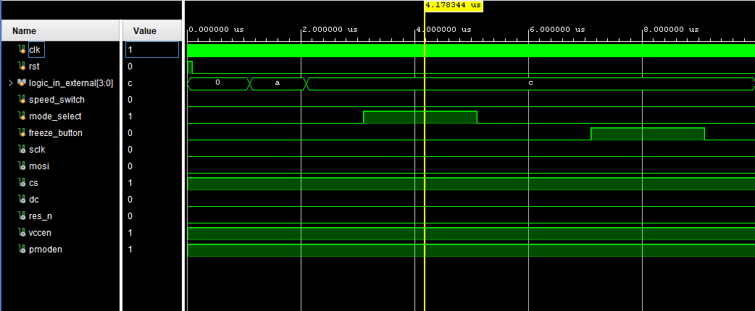

1. **Conclusion :**

The successful implementation of a logic analyzer display system using the Spartan-7 FPGA (XC7S50CSG324-1) and the Pmod OLEDrgb module shows the power of FPGA-based embedded design. This project has achieved its primary goal: to develop a compact and standalone system capable of capturing and visually representing digital signals in real-time without the support of an external computer or display interface.

By using Verilog HDL, the system efficiently captures 4-bit input signals, processes them in a controlled pipeline, and transmits the resulting waveform data to a 96x64 RGB OLED display via SPI. The design incorporates a clean and modular architecture that separates logic capture, waveform rendering, and SPI communication—each of which was tested.

Future enhancements to the system could involve expanding the number of input channels, using higher-resolution displays for better waveform detail, using frequency generator for producing variety of signals in real time, integrating USB or SD card data logging, or introducing on-screen menus for selecting logic channels, zoom level, or display modes.

In conclusion, the project provides a solid foundation for future work in embedded signal visualization, bridging the gap between academic learning and practical hardware implementation. It proves that with careful design, even minimal hardware resources can be leveraged to create robust, real-time digital tools.

1. **References :**
2. <https://www.realdigital.org/doc/02013cd17602c8af749f00561f88ae21> - The FPGA board manual was referred.
3. [pmodoledrgb_rm-934951.pdf](https://www.mouser.com/datasheet/2/690/pmodoledrgb_rm-934951.pdf) – Pmod OLEDrgb module reference manual.
4. Various pre-existing GitHub projects related to Pmod OLEDrgb module integration.